Ramsey Theory and Social Interactions
Ramsey theory is the study of ________________________ in large structures.

What are two fields, aside from social interaction, in which Ramsey theory can be used?

What are some social examples of social situations where Ramsey theory can be applied?

Look at the graph below. Assume red lines connect friends and blue lines connect strangers. What do you notice about the relationship between friends and strangers? (Hint: Look for triangles.)
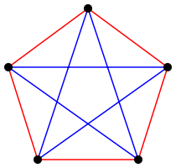

What does a Ramsey number of (6,5) mean?

How many people are needed to achieve a Ramsey number of (4,4)?

How many handshakes could be made with a room of 4 people?

How many handshakes could be made with a room of 168 people?

Draw a graph depicting the handshake problem with a room of 6 people.

